Service Note Daily RES CalAIM 2022-07 – Changes made to existing note – July 2022 Clinicians Gateway
Changes made were:
- Removed Treatment Plan Goals
- Removed Weekly Summary checkbox
- Updated Session Type Drop Down list
- Removed Start and End time fields, retaining only duration
- Removed Location field
- Removed “Add Travel Time”
- Removed “In the Community” field and explanatory text box
- Converted the Optional Daily Narrative box into two required text boxes of Daily Narrative and Next Steps.

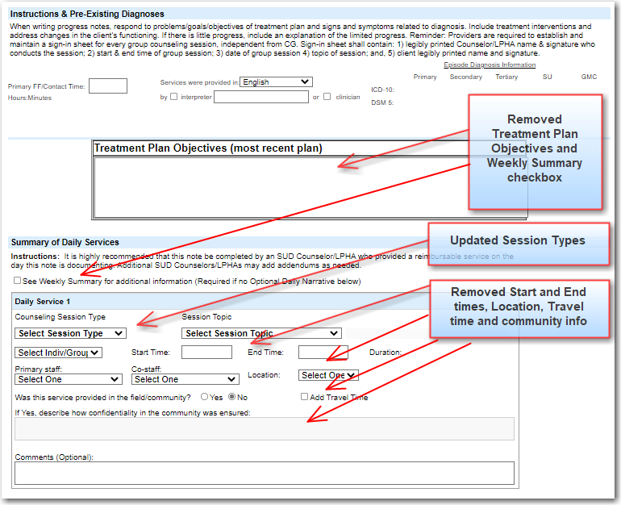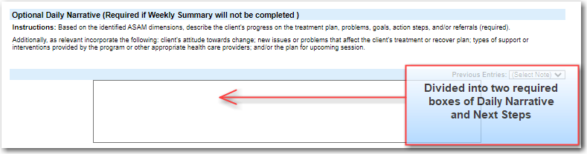
The new note type: (The billing header remains the same)
